Image | 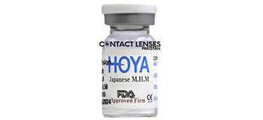
Brand | TIFFANY & CO.
Model Name | BELLA NATURAL
Price | RS 3500
PRODUCT DETAILS

